Year 1 Weekly Overview
Week beginning 21st September 2026
English topic | This week we will revise the meaning of fiction and non-fiction as well as labels. Then we will learn more about captions as another feature of the non-fiction genre.
Maths topic | This week we will learn about subtraction and for this whole term our focus will be on number bonds to 10.
English homework  Set:24.09.2026  Due: 29.09.2026 | In the green English homework book, draw a picture of anything you choose or cut out and stick in a picture or photograph. Then write a caption about your chosen picture. A caption only needs to be one sentence telling us a little bit about what is happening in your picture.  In Year One, every Friday the children complete a Spelling Test.  The words that they need to learn are tucked inside their green homework book. Please keep this sheet to practice writing the spellings on. They are also available on the website.  Go to Year One, Weekly Spellings to find them.  This week the focus is on ee-words.
Maths homework  Set:24.09.2026  Due: 29.09.2026 | 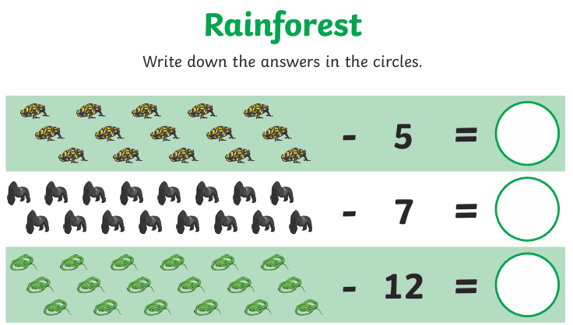
Science | We will continue our Science topic of Animals including Humans. We will be conducting our sense detective investigation to gather information.
Foundation subjects | Art – Portraits and famous artists.  PE – Brilliant ball skills & core strength  Music – Hey You!  Geography – Weather – hot and cold.  RE- Festivals of major religions  Computing – Introduction to Purple Mash.  PSHCE – Making friends: playing and learning together

